Assignment 3 Player’s Guide

1. Game Name: Bug Ops

Authors: Andrew Wright, Jason Phillips

2.

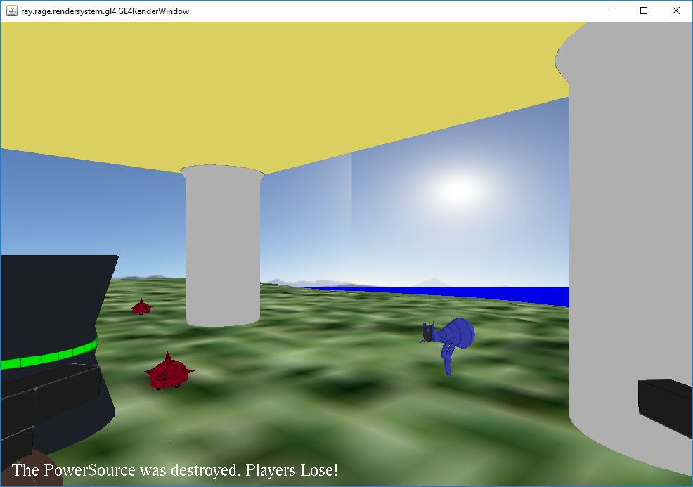

3.

To compile the program from the command line:

1. Navigate to the /src folder.

2. Run “compile.bat” to compile the program in the /bin folder.

To run the program from the command line:

1. Navigate to the /bin folder

2. Run “run.bat” and the program should start.

3. For a multiplayer game, run “startServer.bat” before the clients use “run.bat”

4.

Standard keyboard and mouse required.

5.

This is a game for 1 or 2 players. Approach and press the “E” key to start the power source. The bugs will then approach and attempt to destroy the power source. You must shoot and kill the bugs before they destroy the power source, otherwise you lose.

6. INPUTS

KEYBOARD:

W - Move player forward.

S – Move player backward.

A – Rotate player left.

D – Rotate player right.

E – Start the Power Source (must be touching it)

Escape – Quit the game (this will crash, this is a known issue, to close the program, use Alt+F4)

MOUSE:

Move mouse left/right – Rotate camera left/right

Move mouse up/down – Pitch camera up/down

Left Mouse Button – Fire a bullet

7.

This program uses a script to spawn the enemies into the game world and it also sets their initial locations.

8. Genre: (Action) First Person Shooter.

Theme: SCI/FI

Player and World Dimensionality: 3D

Activities: Combat

9.

External Models: We created models for 2 players, 2 different enemies, bullets, a power source, and architecture (pillars and a roof).

Network Multiplayer: Player positions, enemy health and AI states, and power source health and states are tracked across the server.

Scripting: Used to spawn enemies and set their initial locations.

Skybox & Terrain: Our game implements a skybox and a terrain with height mapping.

Lights: There are two lights above the power source. One of them is turned on when the power source activates, and turns off when the power source dies.

3D Sound: The power source emits a low humming sound when activated, and this sound stops when the power source is destroyed.

HUD: The HUD displays the health of the power source at all times, and it only changes to display that players lost if the power source is destroyed, or that players won if the enemies are all killed before the power source is destroyed.

Hierarchical SceneGraph: All of the monster nodes are children of a parent node called the MonsterGroupNode.

Animation: There are animations for the ArmorAnt walking, attacking, and dying states. Players also have animations for walking and dying.

NPCs: The game implements enemies to fight. They are controlled by custom node controllers that use states to decide what to do next.

Physics: Enemies and the players are affected by gravity, provided by the physics engine.

10.

Fullscreen Exclusive Mode.

Death animations don’t display.

Player animations don’t play for ghost avatars.

Sound is not 3D. No attenuation occurs.

11.

No techniques were used in this game that went beyond the requirements.

12.

Andrew Wright:

Action classes, ICollidable interface, entity classes (ArmorAnt, BugTank, Pillar, Tower, PowerSource, Bullet). Scripting.

Models: Pillar, Tower, Bullet (skins & material files for these)

Terrain, Skybox. Physics, Collision Detection.

Jason Phillips:  
Networking Code, Sound Code. AI State Code. Animation code. GhostAvatar classes.

Models: Player 1 & 2(skeleton and animations), ArmorAnt (skeleton and animations), BugTank. (Skins and material files for all of these.)

Sounds.

13.

Andrew Wright:

Textures:

Bullet2.jpg

Island.png

IslandNMap.png

Pillar2.png

Powersource2.png

Tower2.png

Skybox:

Back.png

Bottom.png

Front.png

Left.png

Right.png

Top.png

Models:

Bullet.obj

Pillar.obj

Powersource.obj

Tower.obj

Materials:

Bullet.mtl

Pillar.mtl

Powersource.mtl

Tower.mtl

Jason Phillips:

ArmorAnt.png

BugTank.png

Player.png

Player2.png

Models:

ArmorAnt.obj

ArmorAnt.rkm

BugTank.obj

Player.obj

Player1.rkm

Player2.rkm

Skeletons:

ArmorAnt.rks

Player1.rks

Player2.rks

Animations:

ArmorAntAttack.rka

ArmorAntDeath.rka

ArmorAntWalk.rka

Player1Death.rka

Player1Walk.rka

Player2Death.rka

Player2Walk.rka

Materials:

ArmorAnt.mtl

BugTank.mtl

Player.mtl

Sounds:

Buzz.wav

14.

Grass2.jpg

Retrieve from here: <https://www.textures.com/download/grass0133/41195>

Permission:

<https://www.textures.com/terms-of-use.html>

ARTICLE 5. Use of Content

5.2

You are permitted to:

(b)

incorporate the Content in computer games and 3D models and 3D scenes;

The following assets were provided in the default assets folder distributed by the CSUS instructors for CSC 165 in Spring 2019:

Textures:

Blue.jpeg

15.

RVR 5029 Computers used: XCOM and WOLFENSTEIN